1 What are the advantages of Bootstrap?

Ans Easy to use

Easily made responsive

Device friendly

2 what is a Bootstrap container & how does it work?

Ans it covers whole web page with margin, padding,border,

Example container,container-fluid

3 what are the default bootstrap text setting?

Default bootstrap text setting are arial,sans-serif

4 what do you know about the bootstrap grid setting?

Ans grid system uses 12 columns to make responsive system,we can use predefined grid classes to create custom layouts for it.

1. What are the difference between Bootstrap 4 & Bootstrap 5?

Ans Bootstrap 5 has designed form elements,expands grid system, it has various icons

Bootstrap 4 usesbrowser default form elements,here grid system was introduced,it doesn’t have icons

1. What is the Button Group,& class for a basic button group?

Ans Button group is a name of class with different functionality with it. Example class=.btn btn primary

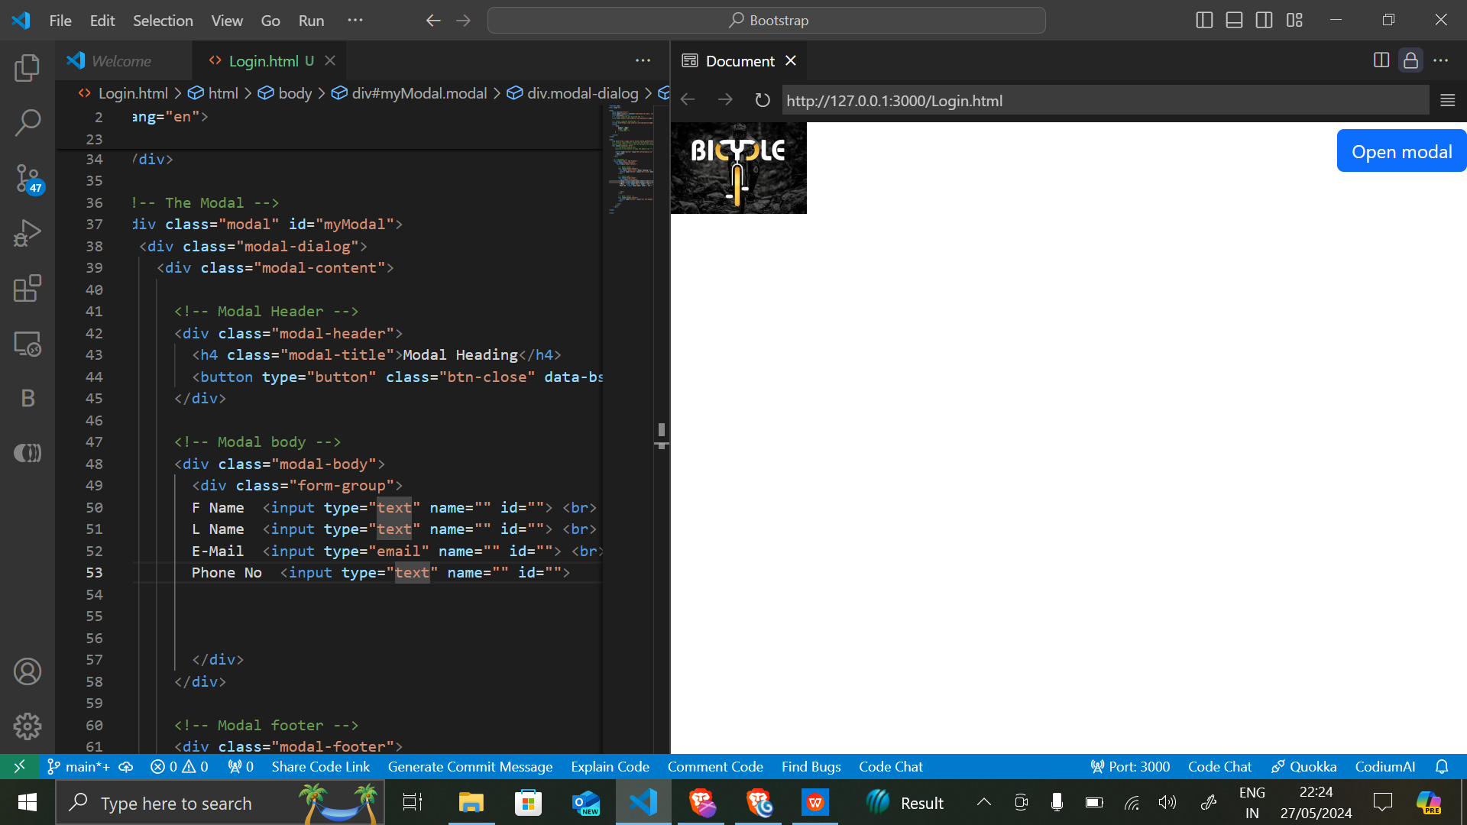

How can you use bootstrap to make thumbnail?

Ans We can use thumbnail class with img tags for it

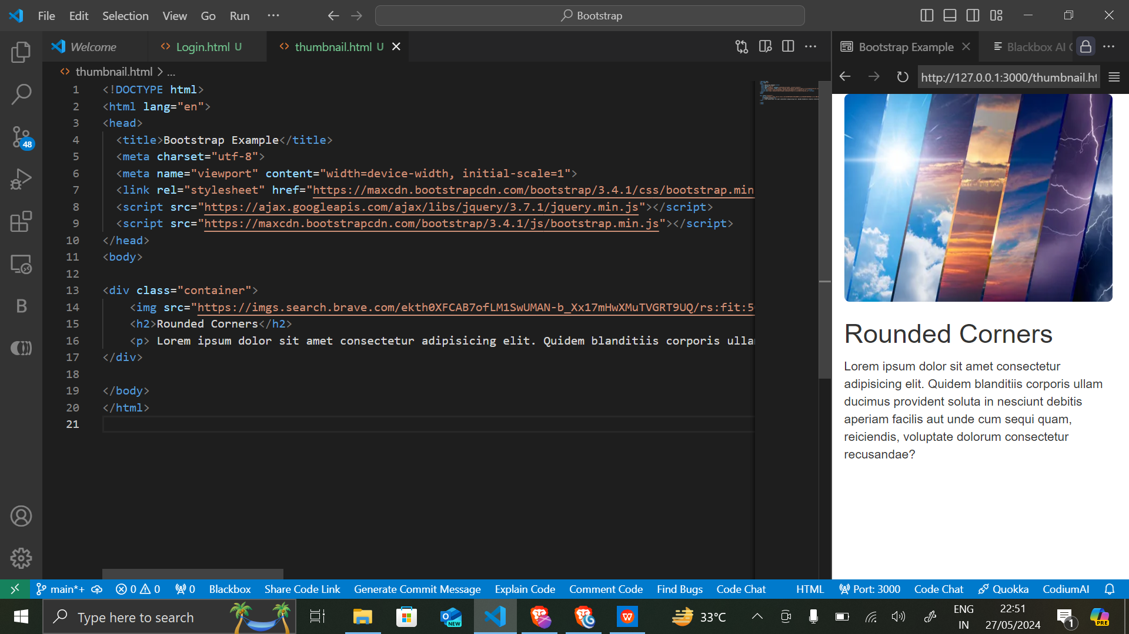

In Bootstrap 4 what is flexbox?

Bootstrap 4 flexbox is used for grid layout,it’s a predefined class in it

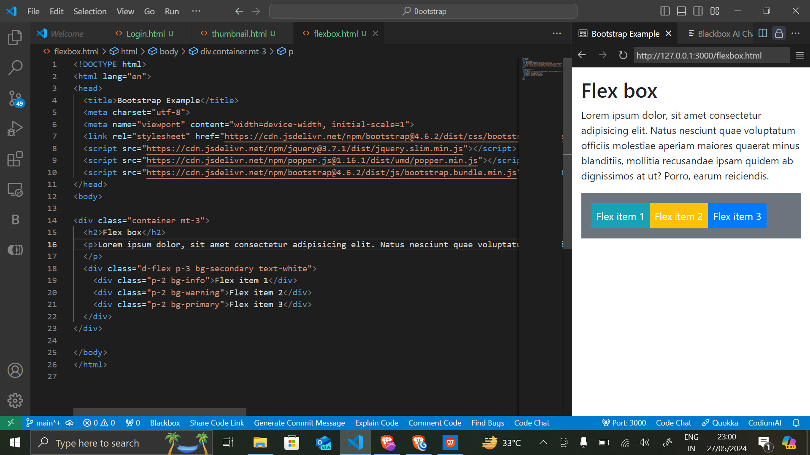

How can we make alert in bootstrap?

?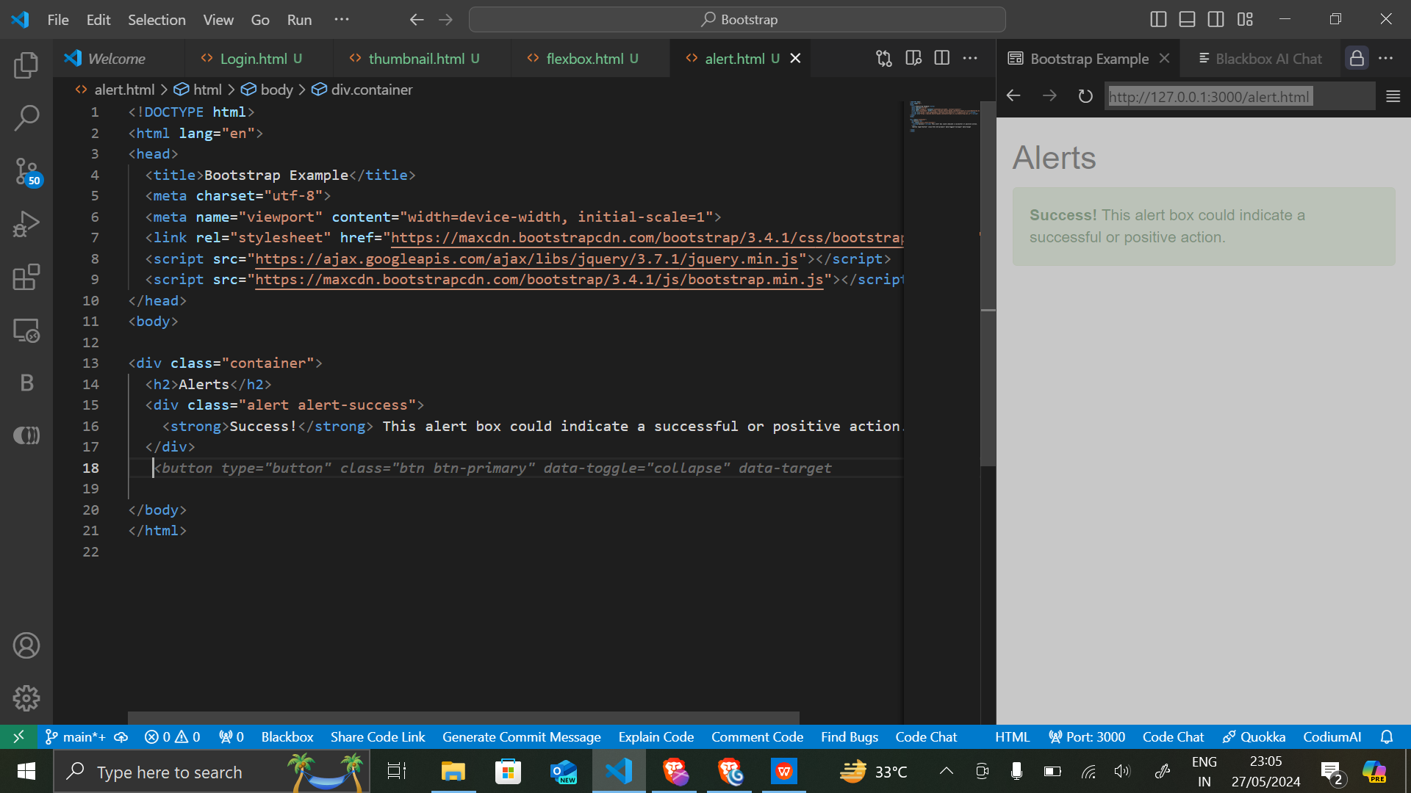

How can we create a card in Bootstrap?

